Project Design Phase-II
Technology Stack (Architecture & Stack)

Date | 19 February 2026
Team ID | LTVIP2026TMIDS74048
Project Name | Rising Waters: A Machine Learning Approach to Flood Prediction
Maximum Marks | 4 Marks

Technical Architecture: Rising Waters
The system architecture for the Rising Waters: Flood Prediction project integrates multi-source data ingestion, temporal deep learning, external meteorological API integration, and a GIS-enabled web application.
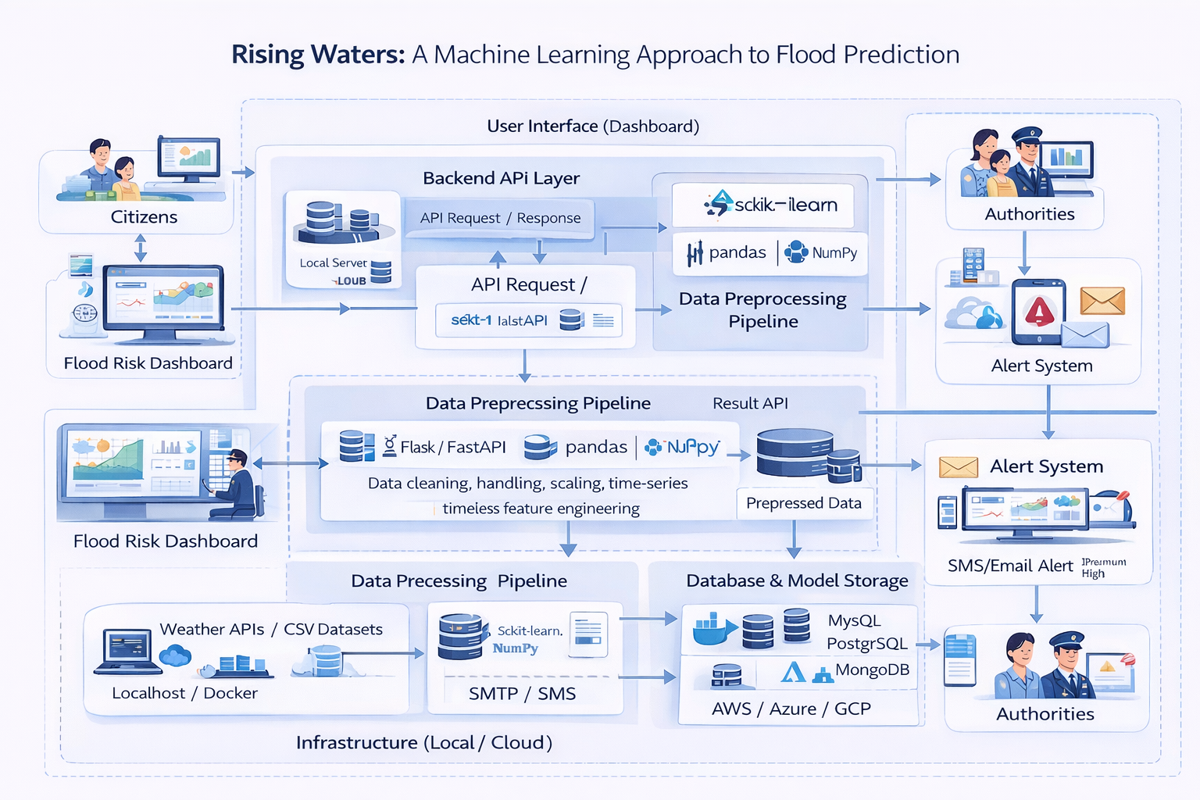
Table-1: Components & Technologies

S. No | Component | Description | Technology
1 | User Interface | Flood risk dashboard, district-wise monitoring, alert visualization | HTML, CSS, JavaScript / React (Optional)
2 | Application Logic | API endpoints, request handling, prediction routing | Python (Flask / FastAPI)
3 | Data Collection Layer | Fetch rainfall, river level, and weather data | Weather APIs / CSV datasets
4 | Preprocessing Pipeline | Missing value handling, scaling, time-series feature engineering | scikit-learn, pandas, NumPy
5 | Machine Learning Model | Flood risk classification & probability scoring | Random Forest / XGBoost / Logistic Regression / LSTM
6 | Database / Storage | Store environmental data, flood risk records, logs | MySQL / PostgreSQL / MongoDB
7 | Model Artifact Storage | Store trained model files | PKL / Joblib
8 | Alert System | SMS/Email notification for high-risk alerts | SMTP / SMS Gateway API
9 | Infrastructure | Local deployment & scalable cloud deployment | Localhost, Docker (Future), AWS/Azure/GCP (Future)

Table-2: Application Characteristics
S. No | Characteristics | Description | Technology
1 | Open-Source Frameworks | ML and backend built using open-source tools | Flask/FastAPI, scikit-learn, pandas
2 | Security Implementations | Secure API endpoints, role-based access, data protection | HTTPS, JWT/Auth, Data Encryption
3 | Scalable Architecture | Modular layered design supporting multiple districts | 3-layer architecture, Docker (Future)
4 | Availability | System runs continuously during monsoon season | Cloud VM, Load Balancer (Future)
5 | Performance | Near real-time flood prediction | Optimized inference pipeline
6 | Reliability | Consistent preprocessing using saved model artifacts | Saved scaler & trained model
7 | Maintainability | Modular code structure for easy updates & retraining | Layered project structure

